BLUE C Beach Litter Monitoring No. 01 – Bulgaria (BRTA Partner)
Name & position of main author: |  | Ms. Fani Semerdjieva- Marine Litter Coordinator, Bulgaria
Name & position of contributors: |  | Ms. Jana Ivanova (BLUE C Project coordinator)
Places visited |  | Beaches of coastal Burgas Region, Bulgas
Objective/purpose of field visit: |  | - Selection of beach for monitoring in Burgas region according to OSPAR Requirements
Summary: Ms. Fani Semerdzhieva (BLUE C Mariene Litter expert) and Ms. Jana Ivanova ( BLUE C Project coordinator) visited several beaches in Burgas Region (Bulgaria). During the fieldwork, 3 beaches have been visited and reviewed according to project provided criteria and monitoring plans. The visits were organised in order to select the beach that will be monitoring.
Project name | BLUE C – BSB00020
Start date | 15-12-2024
Final date | 17-01-2025

Marine litter monitoring campaign in Burgas region, Bulgaria had to be carried out by the end of January, 2025. This has been planned in the framework of the BLUE C project, that has started in September 2024
Burgas Region is located along Black Sea coast of Bulgaria. Six of thirteen municipalities of Burgas region are on the Black Sea cost- Nessebar, Pomorie, Burgas, Sozopol, Primorsko, Tzarevo Municipalities. Beaches in Burgas Region are composed of mainly sand .
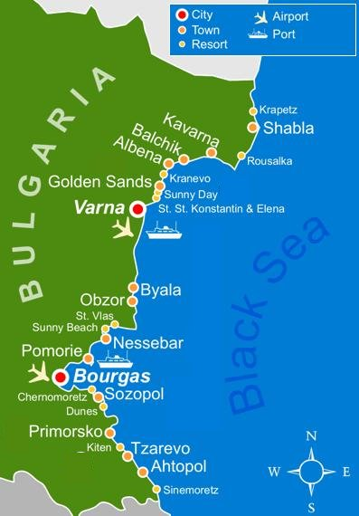
Map 1 of the Bulgarian Black Sea coast.

In order to reach project objectives following activities have been carried out:
- "Guideline for Monitoring Marine Litter on the Beaches in the OSPAR Maritime Area" document was carefully studied and agreed that provided methodologies are appropriate to choose for the project implementation in Burgas region.
- A meeting with a representative of District Government was done to receive a list of the beaches which are not rented / under concession for the moment of monitoring.
- The beaches in Municipality of Tzarevo, Sozopol and town of Burgas were visited for the purpose of selection one proper beach for monitoring. Only beaches which are not rented by the Government were visited.
- Beach was selected and monitoring trial conducted.
- Field work #01 on the selected beach will be done in January 2025 .
The following program was carried out during the field mission:
17 December 2024:
The beach “Popski” in Tzarevo was visited. We saw that the beach is very clean and the monitoring activities are not appropriate for those beache.
# | Place Description | Beach Litter Degree | Suitability
01 | “Popski Beach” Tzarevo  The town of Tzarevo is 70 km. from Burgas. The whole beach is approximately 150 m. long and in January because of strong winds and waves the Beach width was 20-30 m. It is not proper for monitoring activities. Although the beach is very clean. | Low degree of beach litter | Not suitable due to the remoteness from Burgas not enough area.
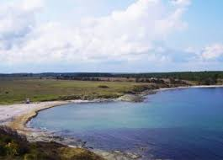Popski Beach

20 December 2024:
-The team visited one of the beach south form Town of Sozopol. The beach is big enough more than 3 km. length, not rented/under concession, no buildings around because it is in the protected area “Alepu”. 30 % of the beach is surrounded by high dunes and the access for people during the periods of monitoring /winter, spring and autumn/ is difficult.
# | Place Description | Beach Litter Degree | Suitability
02 | “Alepu beach” Sozopol  Town of Sozopl on 33km. from Burgas. The beach is 7 km. south from Sozopol. Beach width varies between 100-150 m. Beach is composed mainly of sands. This is an active place used during the tourism season, not rented /free of charge/ and not guarded. Several clean- up activities are done during the years by NGOs and voluntaries. | Medium degree of beach litter. | Not suitable due to difficult access during winter spring and autumn.

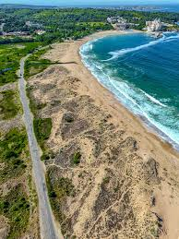Alepu beach

23 December 2024
The last beach planed for visit was in Burgas- Apanasovska Sand Spit Beach. North from the Sea Garden of the town towards the salt pans on the Atanasovsko lake Burgas. The name of the beach is Pomorie Sandspit /sand strip/. It is composed of black sand and is exposed to the open sea on one side and Atanasovsko salt lake on the other side. The beach is accessible for survey all year round and is accessible for marine litter monitoring and is over 2,5 km in length and 50 m. width. The beach is free of buildings because it is protected area “A”.
# | Place Description | Beach Litter Degree | Suitability
03 | Atanasovska Sandspit Beach  The Beach is bordering with a road, located 2 km. from the city centre. Beach is bordered by Atanasovsko lake- protected area. No buildings or summer houses are presented immediately at the area. Not rented and not guarded. | Low-medium degree of beach litter during winter season. During summer season the beach is crowded because it is free of charge, and there are also kite and surf trainings. During summer period the litter degree is very high. | Suitable for litter monitoring. No active human influence seems visible.

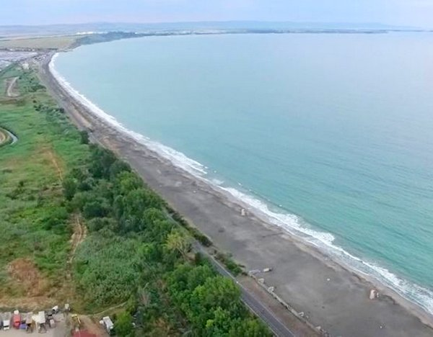 Atanasovska sand spit Beach

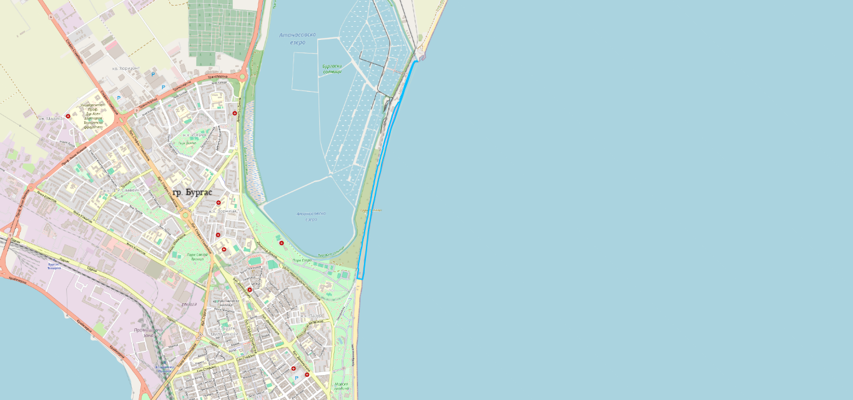
Map 2 The beach is marked in blue.

- Totally 3 not- rented beaches were visited in Burgas region.
- The project reference beach (see Map 2) was selected according to OSPAR methodology.
- The first monitoring is planned for January 2025 and a template will be filled in with the findings.

Conclusion and results

- From the visited and above-described beaches beach N 3 has been chosen as a reference beach for monitoring. Beach is located in the city of Bourgas, which is another argument for selection. Reference beach is governmental owned and not rented for commercial use. From the east it borders with Black Sea and from west is the Protected Area Atanasovsko Lake.

